**Multimedia & Graphics**

**Class Six**

**Lab 16**

|  |
| --- |
| Lab Objectives:Clipart |

In this lecture We will use Clipart to design poster.

# What is Clipart?

## simple pictures and symbols made available for computer users to add to their documents



# Examples:



Clipart provides you a bunch of images which you can easily add to your poster or any other design.

Suppose you want to make a poster where a monkey says he likes banana. So which objects are needed to make this poster? Simply a monkey, banana / banana tree and text tools.

Let’s search these objects inside Clipart.

Click on Clipart

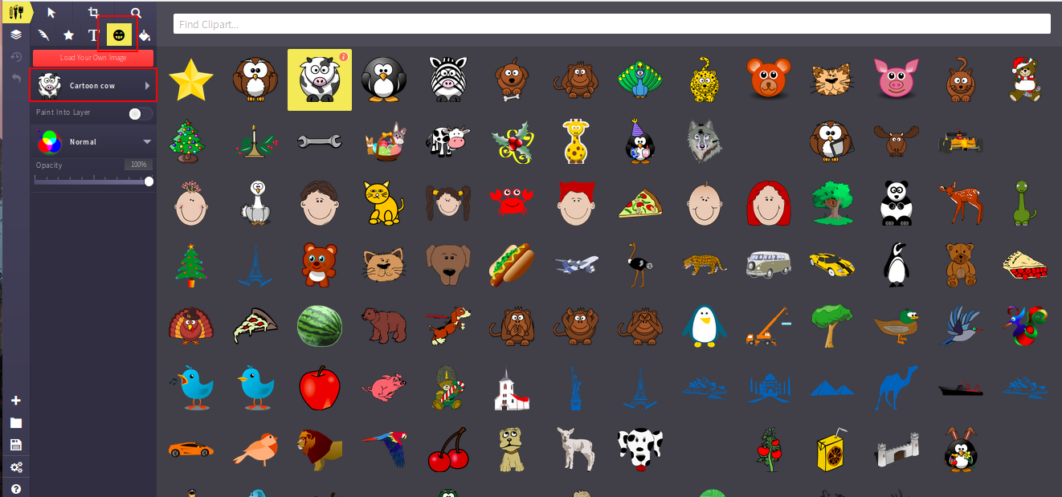

Search for banana clipart

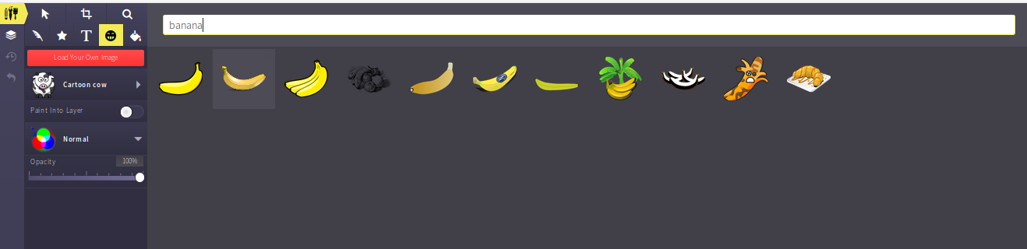Yes we have found some banana here, choose one of them

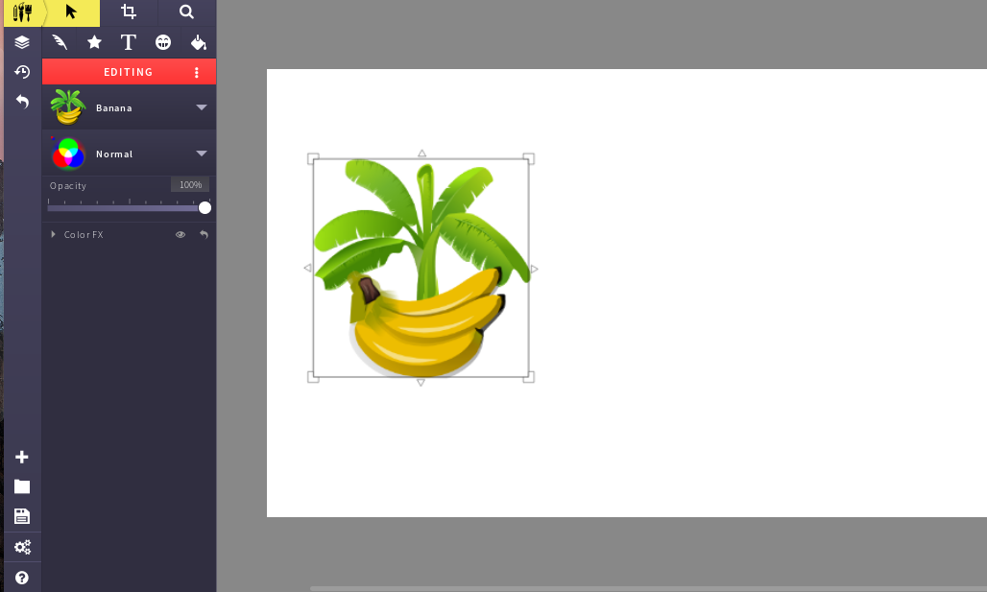

You can use select tool to move your object, also you can use zoom option to resize your canvas.

Now search for monkey and select one of them

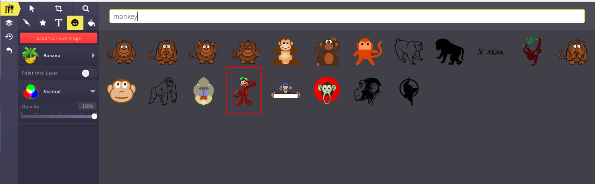

Now a monkey with banana

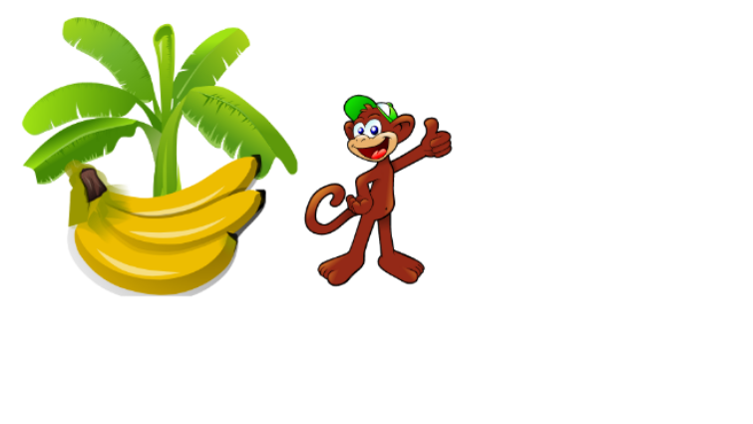

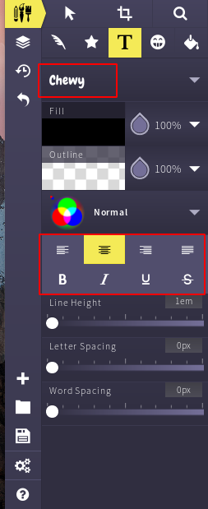Now use text tool to write something. Click on text tool

There are lots of fonts. We have used “Chewy” . there are also text formatting option, You can apply **Bold** text style or *Italic* style, you can set the dimension of your text.

Now write something.

We have added a text “I Like Banana”. Now you can add some Style to your text.

Move your text using Select tool.

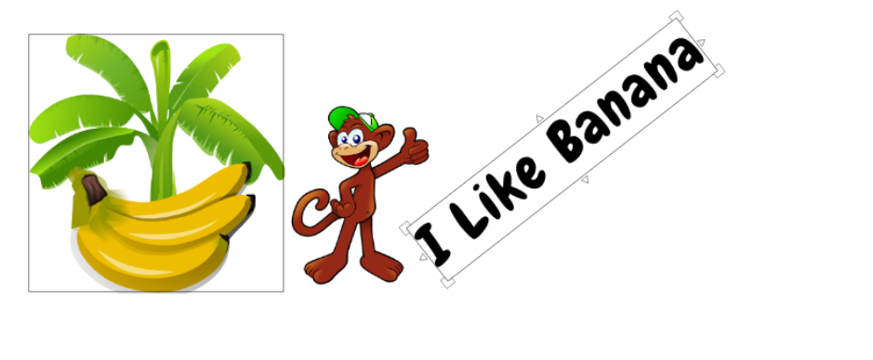

You can curve your text easily. Just select text and go to the corner of the text box and move your mouse.

Add any color with your text



You can change your background color. Click on vector fill and choose any color you want.

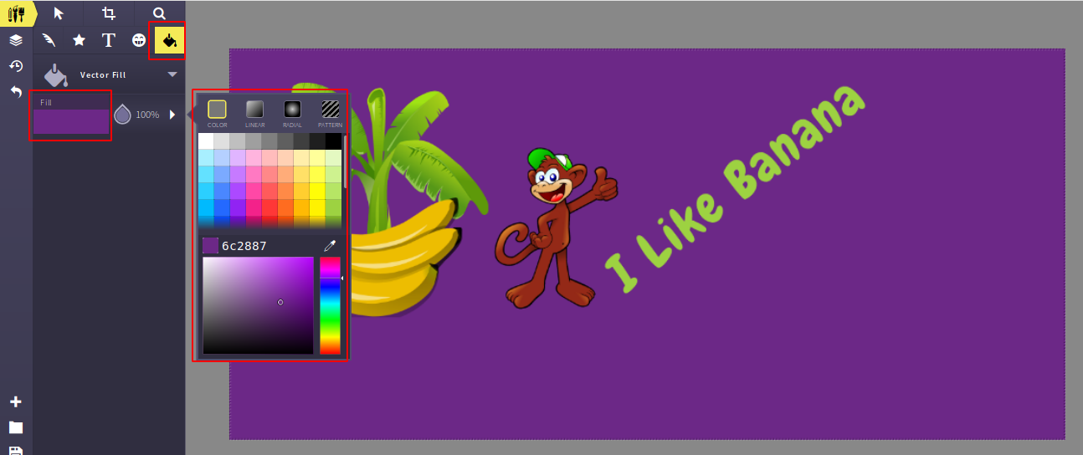

So here we go

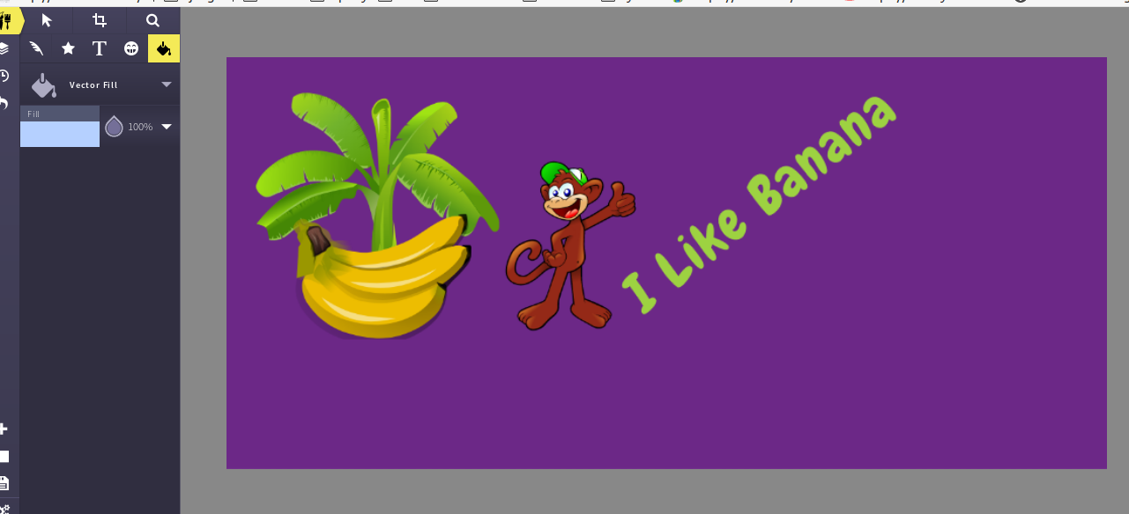

It’s time to export our image. Click on export Icon and save as JPG

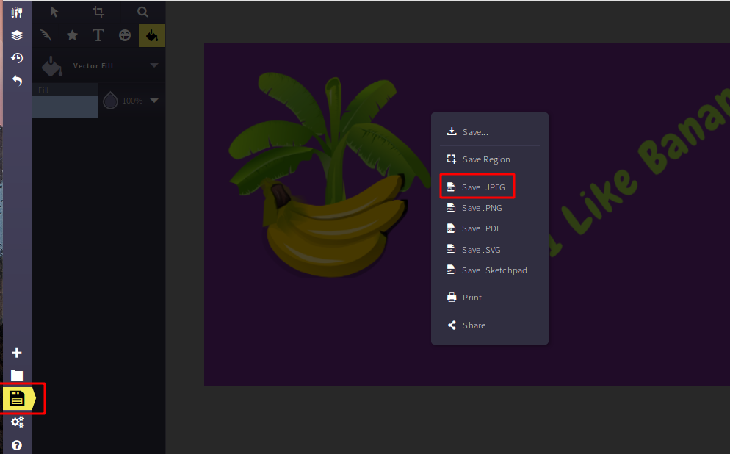

Give the saving permission

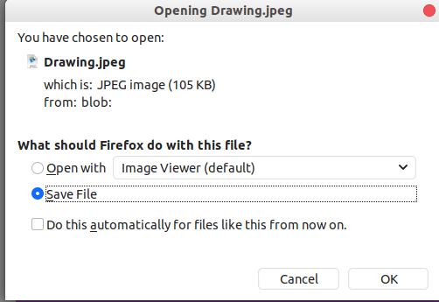

Go to your downloads folder and open your poster.

And here is our final poster

